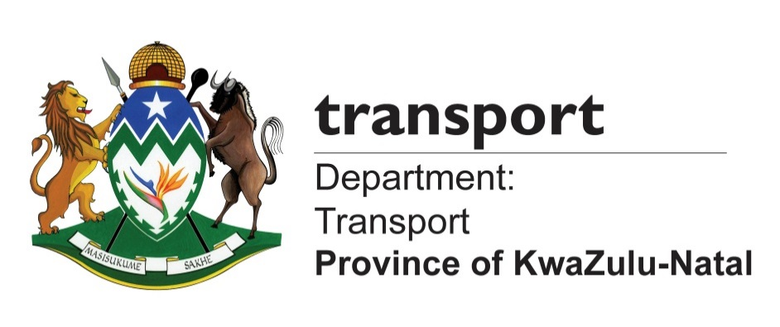

MEDIA ADVISORY

Wednesday, 29 November 2017

PRESIDENT ZUMA TO OFFICIALLY OPEN THE DUMISANI MAKHAYE DRIVE

President Jacob Zuma will on Saturday, 02 December 2017, officially open for public use the new Dumisani Makhaye Drive (Main Road 577) in Clermont, Durban as part of Government’s nationwide programme of infrastructure development.

The completion of the R1.3 billion road infrastructure project makes it the biggest road infrastructure development in the country in five years and epitomises government’s service delivery excellence. For the first time, the road will connect, among others, the communities of Newlands, KwaMashu, Inanda, KwaDabeka, Clermont and Pinetown.

Significantly, the road will also be a new, alternative route to the King Shaka International Airport for traffic coming from the Pietermaritzburg and Pinetown areas, which will now ease traffic congestion on the N2/N3 interchange.

The road is being named after the late struggle hero, Mr. Dumisani Makhaye, who also served in various capacities including as MEC in the KwaZulu-Natal Provincial Executive Council.

The naming of the road is part of the KwaZulu-Natal provincial government’s Roads Naming and Renaming Legacy Project, which is aimed at naming and renaming roads and bridges infrastructure in the province’s roads network to help communities reclaim their historical legacy, pride and heritage by giving new, meaningful names to new and existing provincial roads and bridges.

The completion of the main road works, which paves the way for the use of the road by members of the public, especially motorists, is a major step in the government’s drive to create easy access for communities for socio-economic development.

The Dumisani Makhaye Drive spans the uMngeni River and provides a strategic link between Duffs Road in KwaMashu to Dinkelman in New Germany. It cuts off a massive 16 kilometers for traffic using N3 to connect to N2, and will help eradicate the legacy of colonialism and apartheid-based spatial planning.

The details of the official opening of the road are as follows:

DATE: Saturday, 2 December 2017
TIME: 10h30
VENUE: Sugar Ray Xulu Stadium, (Clermont), Durban

Media attending the event must please send their ID/Passport numbers and other details for accreditation to Mandisi Mhlongo on 082 805 9072 or mandisi.mhlongo@kzntransport.gov.za or Akhona Dlamini on 082 678 6417 or akhona.dlamini@kzntransport.gov.za or Vukile Mathabela on 071 480 5205 or vukilemathabela@gmail.com

Enquiries: Dr Bongani Ngqulunga on 082 308 9373 or bongani@presidency.gov.za
Ends

Issued by the Presidency
Pretoria

www.thepresidency.gov.za

